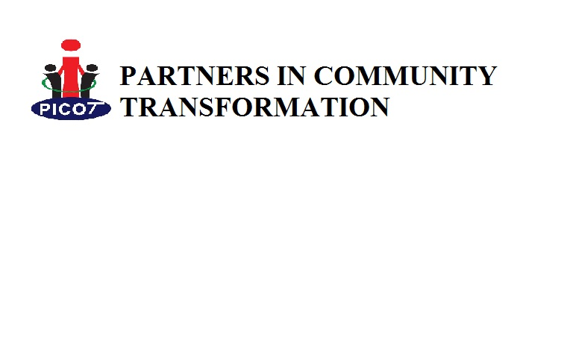
Plot 9/11 Ben Enzama Road off Lurujo Road
Behind Koboko Town Council Offices,
P.O Box 82, Koboko
Tel: +256(0) 790 913896 E-mail:inforpicot@gmail.com

PICOT PROFILE
Background

Partners’ in Community Transformation (PICOT) is a non-profit making local Non-Governmental Organization registered with National NGO Board (registration number 10147) on the 20th day of September 2013. PICOT was formerly known as Koboko Youth in Development (KOYID) founded in 2005 and registered as a Community Based Organization with Koboko District on 25th April 2006.
The organization came into existence in 2005 following the realization by a group of progressive youth who felt concerned about the development needs and challenges affecting the youth, women and the wider community of West Nile District. Among the challenges noted with concern to be addressed include but not limited to HIV/AIDS, Sexual Reproductive Health, poverty, low education attainment, poor governance, youth unemployment and environmental degradation.

Since then PICOT strives at creating meaningful platforms for youth, women, people with disabilities and entire community to participate in community affairs. As such, in all its undertakings, PICOT works in close cooperation with Local Governments and development partners in supporting community driven development initiatives.

PICOT’s core program areas include Community Health Promotion, Holistic Education Promotion, Community Economic Empowerment, Community Governance and Human Rights, Environmental Conservation, and Organizational Capacity Development.

To carry out its mandate effectively and to have greater impact, PICOT has developed its vision, mission and motto as a guide in program interventions and activities as noted below.

Vision Statement: Holistically Transformed Communities

Mission Statement: Working with communities and development partners to identify, mobilize and utilize the available resources for sustainable development

Motto: Inspiring Communities to Transform Lives

Core value, principles and beliefs

1. Voluntarism,
2. Team work,
3. Gender inclusiveness,
4. Accountability,
5. Transparency,
6. Community participation
7. Partnerships.

INTERVENTIONS

THE OVERALL GOAL
An empowered, healthy and productive population for sustainable development

PURPOSE
To promote positive behaviour change for a responsible, healthy and productive life among the communities

CORE OPERATIONAL AREAS

PICOT focuses on six core areas with the aim of enabling the organization to realize its overriding vision, mission and objectives. These core mandate areas include;

1. Community Health Promotion.
2. Holistic Education Promotion.
3. Community Governance and Human Rights.
4. Environmental conservation campaigns.
5. Community economic empowerment.
6. Organizational capacity development.

THEMATIC AREA I: COMMUNITY HEALTH PROMOTION (COHEP)
Broad objective: To promote holistic community health interventions for healthy living
- HIV/AIDS prevention and care
- Sexual and Reproductive Health (adolescents’ sexual health, family planning, antenatal care, PMTCT, sexually transmitted infections and sensitization on preventable diseases among others)
- Water, sanitation and hygiene (and household sanitation, clean water and hygiene promotion to prevent infections and outbreak of epidemics)
- Behavior Change communication
- Care and support for Orphans and vulnerable children as well as people living with HIV

PICOT believes that communities’ are resourceful and that empowered communities are a prerequisite for improving individual and community health. Together with the community, the organization shall mobilize resources and create awareness on the need to promote access to appropriate health services in the community for a healthy living now and in future.

THEMATIC AREA II: HOLISTIC EDUCATION PROMOTION
THEME: HOLISTIC EDUCATION FOR SUSTAINABLE COMMUNITY DEVELOPMENT (HESCODE)
Broad objective: To promote holistic education for sustainable community development
A- School Based Education (SBE)
• Promotion of debate and public speaking
• Career guidance, counseling and mentorship
• Capacity building for teachers, administrators, school management committees and student leaders
• School essay competitions
• strengthening of school based clubs and associations
• Support initiatives to promote gender sensitive education
• Education Fund to support needy but brilliant children

B- Community Based Education (COBE)
➢ Continuous community sensitization on the importance of education and parent’s involvement in the education of their children
➢ Promotion of Functional Adult Literacy (FAL) in the community
➢ Promotion of non-formal vocational skills training for school for youth, and women

THEMATIC AREA III: COMMUNITY GOVERNANCE AND HUMAN RIGHTS
Community Governance has increasingly gained popularity in the recent development paradigm. It is the community level management and decision-making that is undertaken by, with, or on behalf of a community, by a group of community stakeholders. The focus on ‘community’ rather than organization, local government or the public sector is the distinguishing feature of community governance vis a vis the other forms of governance. However, for community governance to be effective, it must be about more than process, it also must be about getting things done in the community. And what gets done must make a difference with results measured. Community governance shall be guided by the GEM approach as explained below:
G – Democratic governance: Where leadership and decision-making by elected community leaders including Councillors, is based on a sound appreciation of community issues and needs and a commitment to effective community engagement in their own affairs.
E – Civic engagement: Where councils employ effective techniques to enable active citizens to influence the formulation and implementation of public policies that affect their daily lives.
M – Organization management: Where public value management policies and practices are embedded in the workplace culture, acknowledge citizen participation rights and ensure that the outcomes of community engagement inform decision-making. This approach is preferred because consultation and engagement starts with exploring existing community needs.

THEMATIC AREA IV: COMMUNITY ECONOMIC EMPOWERMENT

We believe that when youth, women and persons with disabilities develop, the community also develops and stands to benefit from their empowerment. Engaging the population in small scale income generating activities at individual, group and household level can act as a spring board for greater economic empowerment to ameliorate perils associated with economic marginalization and manipulation. Economic empowerment is intended to enable communities become more responsible; organize and plan together; develop healthy options; empower themselves; reduce ignorance, poverty and suffering; create employment and economic opportunities; and achieve social and economic goals. Hence imparting life skills and entrepreneurship skills through trainings and other development initiatives are potential platforms that can enhance and harness people’s potentials for integral community development.
- Non-formal vocational skills
- Agriculture
- Entrepreneurship
THEMATIC AREA V: ENVIRONMENTAL CONSERVATION CAMPAIGNS

Communities that embrace good environmental practices like tree planting, proper management and disposal of waste and strives for a clean and protected environment substantially contributes to the sustainable well-being of its inhabitants. We believe that the community can take charge of its environs for a healthy living now and in future by proactively engaging them on the need to protect and conserve the environment.
- Community awareness
- Tree planting
- Energy saving schemes

THEMATIC AREA VI: INSTITUTIONAL CAPACITY DEVELOPMENT

Given the growing need for organizations to thrive in an increasingly competitive environment amidst scarce resources, it is prudent that the organization’s technical, logistical and financial mechanisms are mobilized, organized and utilized to enhance effectiveness and efficiency in its undertakings. Therefore, building staff capacities in critical areas of research, financial and programme documentation, monitoring and evaluation, resource mobilization, networking and partnership and strategic planning over time are essential for the organization’s continued growth, relevance and sustainability.
- Staff capacity development
- Formulate develop organizational policies
- Equipment and supplies

PAST AND ONGOING PROJECTS UNDERTAKEN BY PICOT
S/No | Project Title | Donor | Duration
 | Amplifying Voices for Youth Health | Planned Parenthood Federation of America - PPFA | 01/04/2016 to 31/03/2018  01/01/2015 to 31/03/2016
 | Youth Advocacy on Sexual Reproductive Health to increase awareness, access and utilization of available Reproductive services in West Nile, Uganda | Planned Parenthood Federation of America - PPFA | 01/04/2016 to 31/03/2018  01/01/2015 to 31/03/2016
 | Promoting Youth Social and Economic Empowerment through Civil Society and Local Authorities (Youth SEECs) | European Commission/Union through Aga Khan Foundation Uganda | 01/08/2016 to 31/07/2020
 | Community Responsibility to Enhance Transparency and Accountability (CRETA) | Inspectorate General of Government (IGG) | 01/02/2018 to 31/06/2018
 | Strategies to Combat HIV/AIDS Project (SOCAH) | Infectious diseases institute (IDI) | 01/10/2018 to 31/03/2018
 | Enhancing community participation in governance and accountability in health service delivery in West Nile | Independent Development Fund (IDF) | 01/09/2016 to 31/12/2018
 | Prevention of HIV/AIDS Among Workers of ZHONGHAO ENGINEERING OVERSEAS CO.LTD | World Bank Through ZHONGHAO ENGINEERING OVERSEAS CO.LTD | 01/01/2017 to 31/04/2018
 | Strengthening Education Systems in East Africa (SESEA) | Aga Khan Foundation Uganda | 01/02/2015 to 30/09/2016
 | Strengthening civil society for improved HIV/AIDS and OVC service delivery in Uganda (SCIPHA) | Civil Society Fund through Joint Clinical Research Centre (JCRC) | 01/01/2015 to 31/12/2015
 |  |  | 01/01/2014 t0 31st/12/2014
 |  |  | 2013
 |  |  | 2012
 | Intergovernmental Authority for Development (IGAD) Regional HIV/AIDS Partnership Program | IGAD through Uganda AIDS Commission | 2013/2014
 |  | IGAD through Uganda AIDS Commission | 2011-2012
 | Citizens Watch IT/Citizens Manifesto in Action | HIVOS and Oxfam through Community Empowerment for Rural Development (CEFORD) | 2013/2014
 | Uwezo Annual Assessment of learners competencies in numeracy and literacy | Uganda National NGO Forum | 2012/2013
 | School Debate Programme on Youth Involvement in Good Governance | National Debate Council Uganda | June to August 2010
 | Regional Outreaches Addressing HIV/AIDS Through Development Strategies (Roads II) | Family Health International/USAID | 2009/2010
 | Youth Empowerment through debate | Open Society Institute | 2009

